Arlind Stafaj CISC 6930 - Data Mining

**Homework 1**

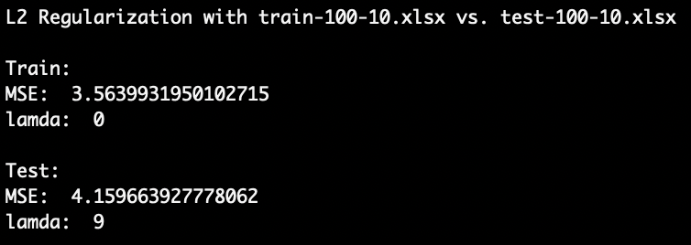**Question 1:**

1. 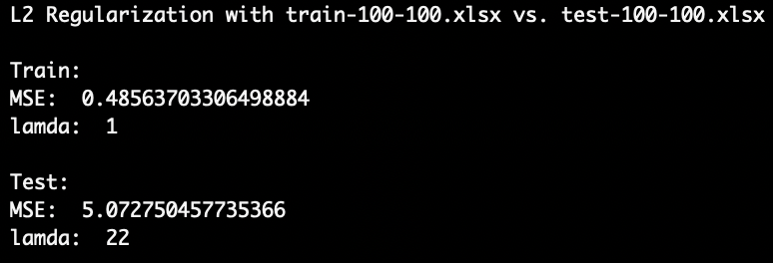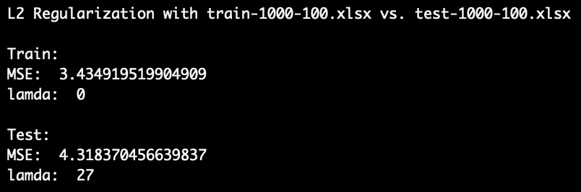

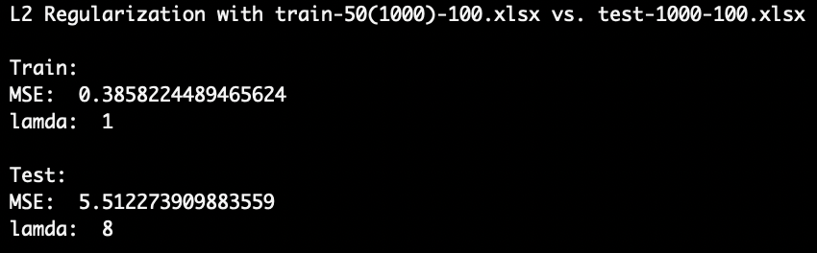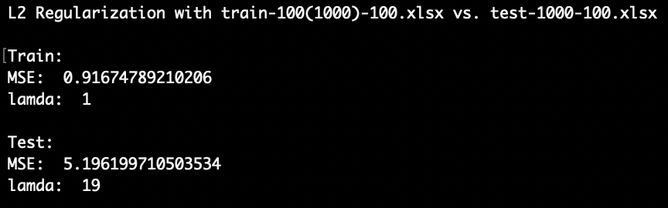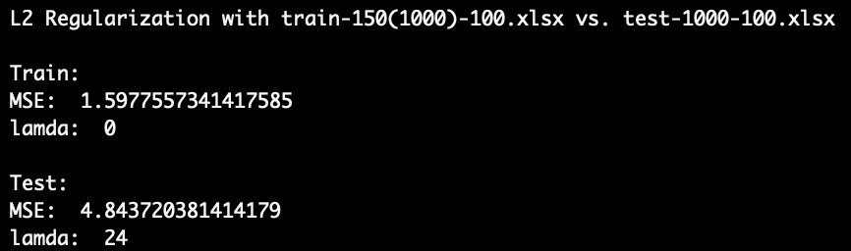

* 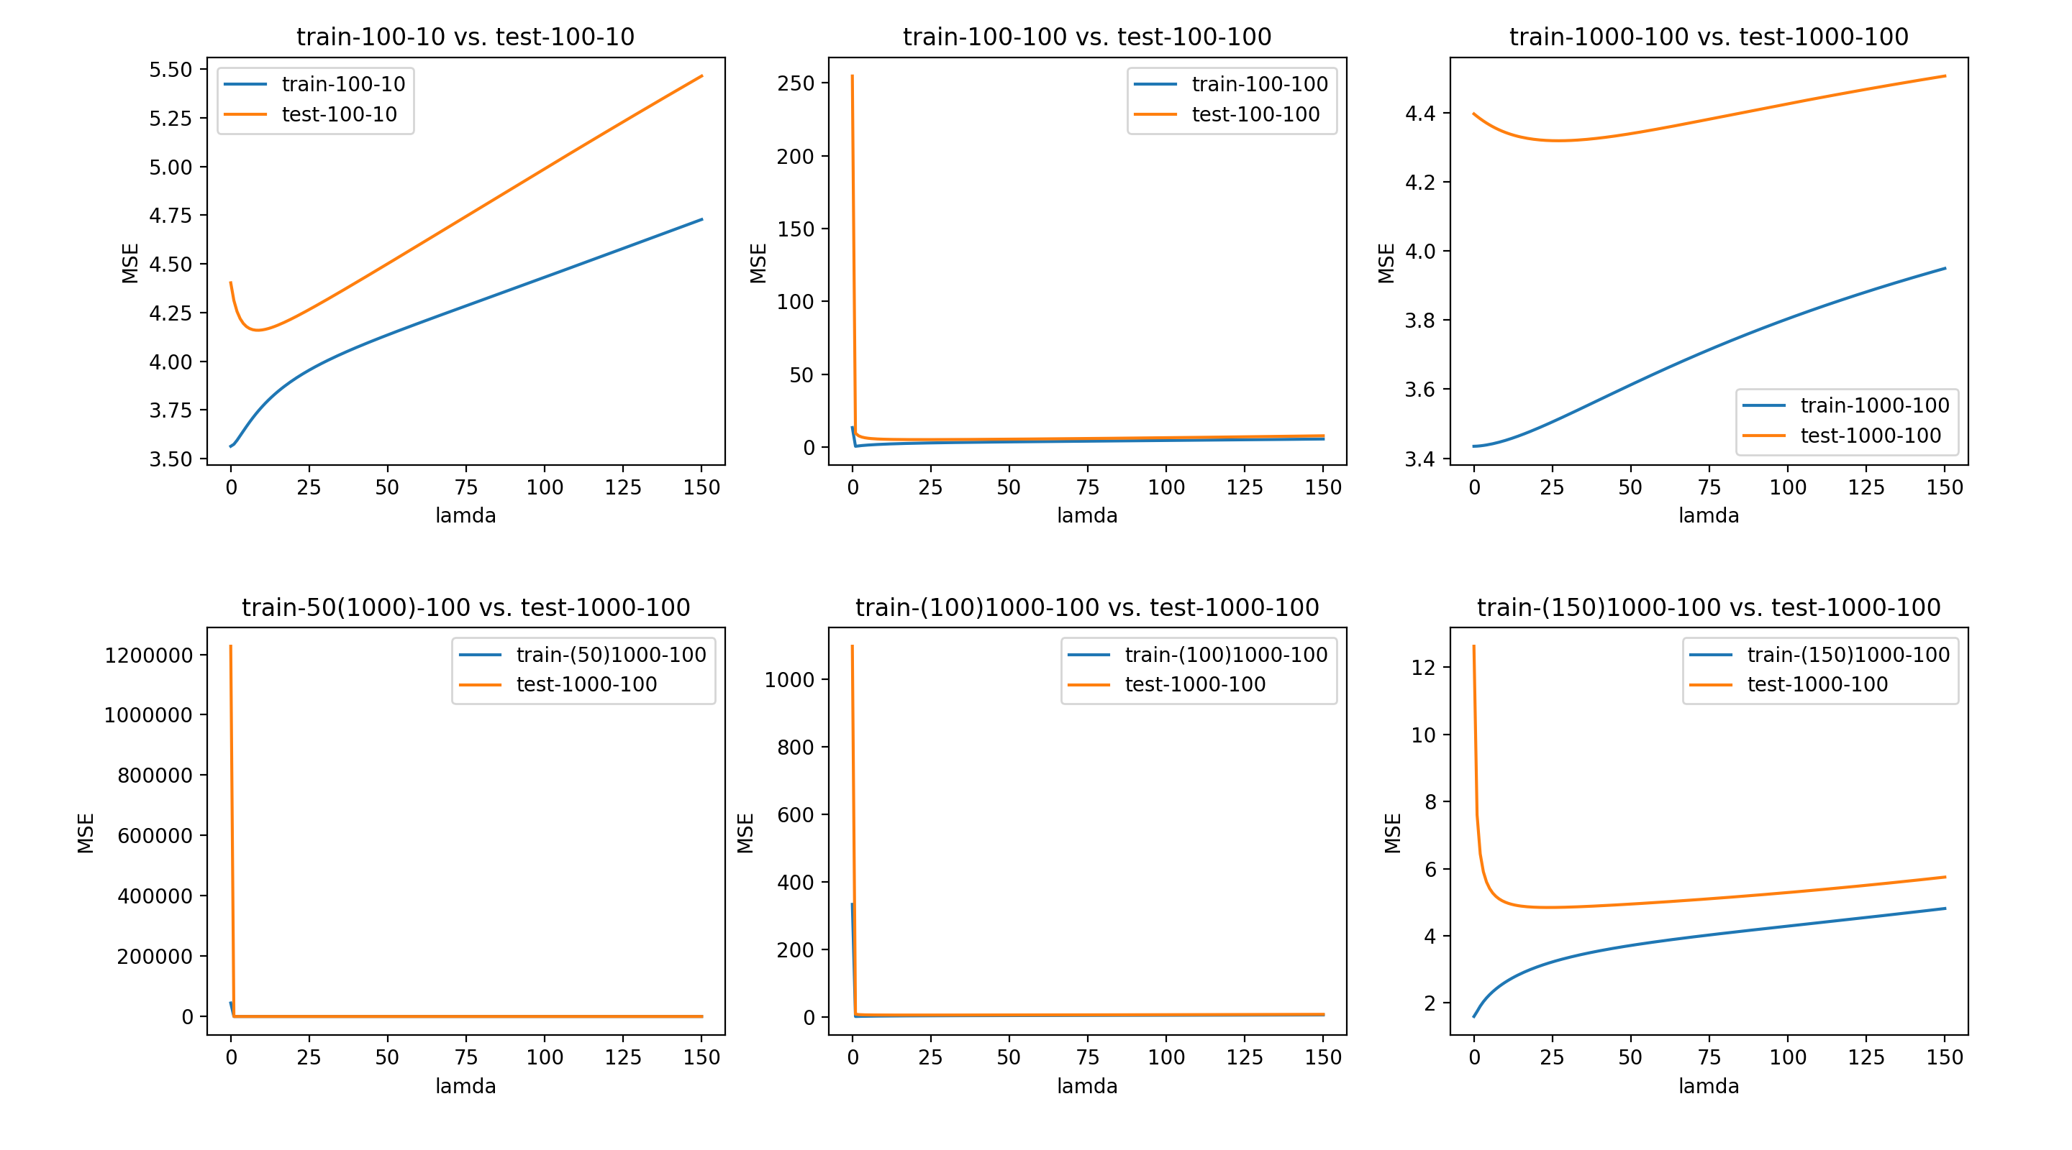For part (a) you can find these results after running code.

1. 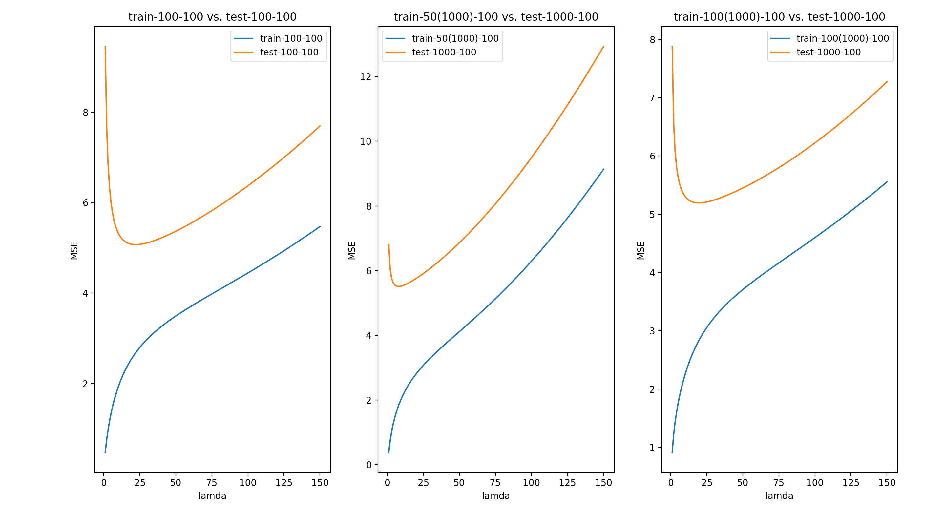 Will be shown after code for question1(b).py is run.
2. The reason $λ=0$ gives abnormally large MSE for data sets in (b) is due to the fact that no regularization results in an overfit model. Overfitting occurs when the line of best fit has high-degree polynomial and fits the train data very well. As result test data will have higher MSE because predictability becomes more difficult due to complexity of high degree polynomial. Above it can be seen that there is too much reliance on a small sample of observation to fit the model.

**Question 2:**

1. best choice of λ value and the corresponding test set MSE for each of the six datasets: 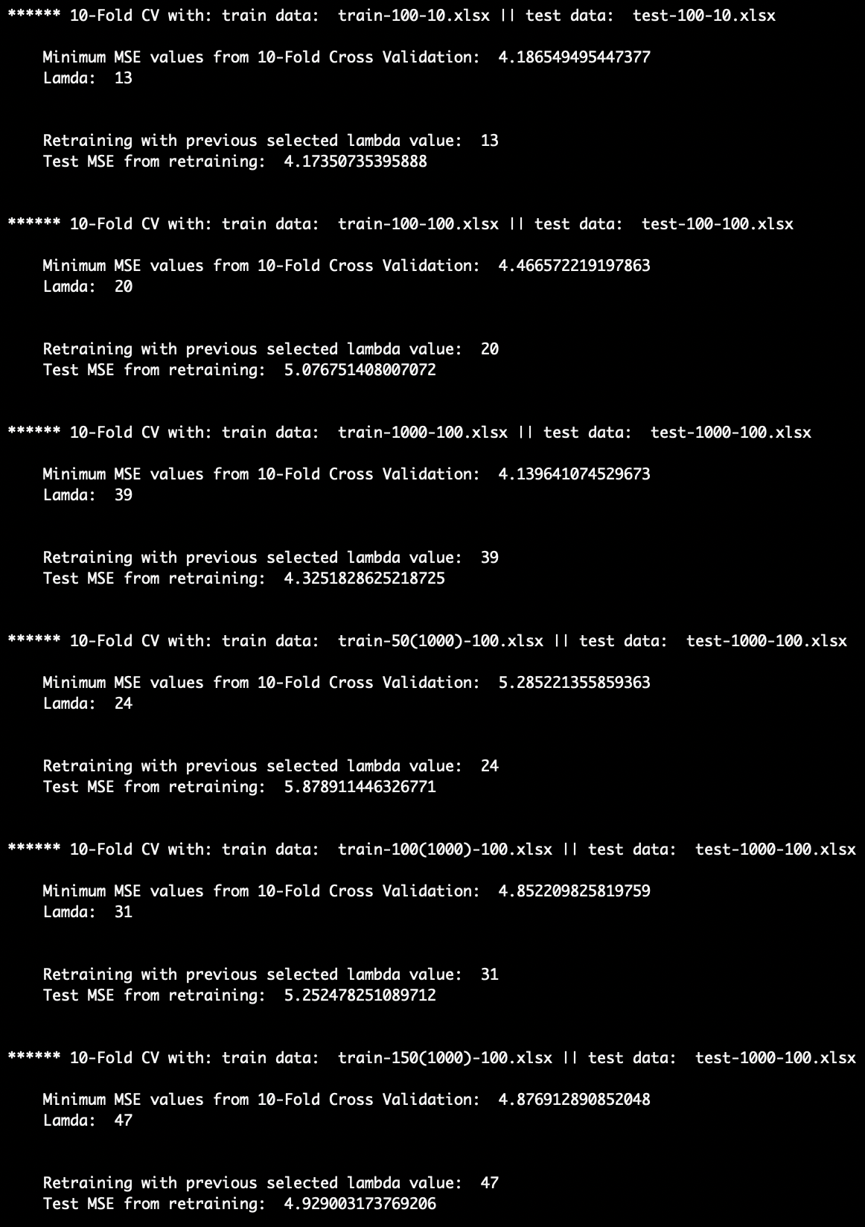
2. The values in 1(a) for lambda are lower than those that were generated by the 10-fold Cross Validation performed. As the data sizes grew the lambda values were visible lower in higher degrees for the results in question 1(a). This is a result of there being only one train data being used to figure a best fit model and then that result being applied to the test data. Through cross validation technique lambda values increased because the train data was divided into 10 parts and tested several times to generate a more accurate model for the test data. This then resulted in the discrepancy mentioned above.
3. A draw-back of the k-fold CV technique is that the training algorithm has to be rerun from scratch k amount of times. This will result in increased repetitions as data increases. If the training algorithm is complex this will result in even further performance issues. Another drawback is that choosing a wrong CV technique will result in poor bias-variance tradeoff.
4. A main factor affection performance of CV is, as mentioned in 2(c) above complexity in the algorithm and increased data cause slowed performance. In addition, by splitting data up we risk missing out on capturing a trend within the data, since data itself is already limited. This results in error increase induced by bias. Bias is the inability of a method to capture a true relationship. Another issue that affects CV is the difference in fits between data sets. This is called variance, and this measures the difficulty in predicting performance with future data.

**